**Homework 2**

**Number: 2017329621139 Name: 徐政辉 Class: 17计科全英文**

1. **Suppose that coverage criterion C1 subsumes coverage criterion C2. Further suppose that test set T1 satisfies C1 and on program P test set T2 satisfies C2, also on P.**

**(a) Does T1 necessarily satisfy C2? Explain.**

Yes. This follows directly from the definition of subsumption. Because a subsumption must satisfy all the criterion of its parent criterion.

The definition of the criteria subsumption is showed below:

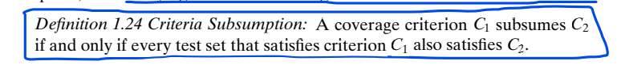

**(b) Does T2 necessarily satisfy C1? Explain.**

No. There is no reason to expect test requirements generated by C1 to be satisfied by T2. Because C2 may contain criteria that didn’t contain in C1 for the reason that C1 is the subsumption of C2. So that test set T2 from C2 may contain element not satisfy C1 criteria.

So it’s doesn’t necessarily that T2 satisfy C1.

**(c) If P contains a fault, and T2 reveals the fault, T1 does not necessarily also reveal the fault. Explain.**

Yes. Because T1 is the test set from C1 which is the subsumption of criteria C2. So that, what the C2’s test set T2 satisfied may not be satisfied with T1 which is the test set of C1. We can think that as a many to one relation, and you can see not every one can satisfy all the many, just some of them,